|  |  |
| --- | --- |
| **Name:** | Bodhisatya Ghosh |
| **Class:** | CSE DS |
| **Batch:** | B |
| **UID:** | 2021700026 |
| **Experiment:** | 10 |

**Aim**: The program r.c initializes n number of semaphores. It first assign count equal -1, which is then used by process p and q. This count is protected by semaphore. It also allocates shared memory of size 40 ints. It waits for process p and q to enter all n1 and n2 elements through different terminals. This program r.c sorts shared data in ascending order. It waits to finish p and q. At end, The program r.c detaches and deletes n semaphores and print the sorted list.  
  
**Code:**

**main.c**

#include <stdio.h>

#include <stdlib.h>

#include <fcntl.h>

#include <sys/stat.h>

#include <sys/ipc.h>

#include <sys/shm.h>

#include <unistd.h>

#include <semaphore.h>

#define TOTAL_ELEMENTS 40

int main()

{

    printf("Main:\n");

    key_t shmkey = ftok("my_unique_key_gg", 0);

    sem_t *sem = sem_open("my_semaphore_for_count", O_CREAT, S_IRUSR | S_IWUSR, 0);

    sem_t *over_sem = sem_open("my_semaphore_for_r", O_CREAT, S_IRUSR | S_IWUSR, 0);

    if (sem == SEM_FAILED || over_sem == SEM_FAILED)

    {

        perror("sem_open");

        exit(1);

    }

    // Intial value of semaphore set to 0

    sem_init(sem, 1, 0);

    sem_init(over_sem, 1, 0);

    int shmid = shmget(shmkey, (TOTAL_ELEMENTS + 1) * sizeof(int), IPC_CREAT | 0666);

    // Last one for maintaining count

    if (shmid == -1)

    {

        perror("shmget");

        exit(1);

    }

    int *array = (int *)shmat(shmid, NULL, 0);

    if (array == (int *)-1)

    {

        perror("shmat");

        exit(1);

    }

    array[TOTAL_ELEMENTS] = -1;

    printf("Waiting for r to complete\n");

    sem_wait(over_sem);

    printf("\nAll operation done\n");

    shmdt(array);

    shmctl(shmid, IPC_STAT, NULL);

    sem_destroy(sem);

    sem_close(sem);

    sem_destroy(over_sem);

    sem_close(over_sem);

    sem_unlink("my_semaphore_for_count");

    sem_unlink("my_semaphore_for_r");

    return 0;

}

**-----------------------------------------**

**p.c**

#include <stdio.h>

#include "semaphore.h"

#include <stdlib.h>

#include <unistd.h>

#include <string.h>

#include <sys/ipc.h>

#include <sys/shm.h>

#include <time.h>

#include <fcntl.h>

#include <sys/stat.h>

#define TOTAL_ELEMENTS 40

int main()

{

    printf("Process p:\n");

    key_t key;

    key = ftok("my_unique_key_gg", 0);

    // sem_t *sem;

    // sem = sem_open("my_semaphore_for_count", 0);

    sem_t *sem = sem_open("my_semaphore_for_count", O_CREAT, S_IRUSR | S_IWUSR, 1);

    if (sem == SEM_FAILED)

    {

        perror("sem_open");

        exit(1);

    }

    int shmid = shmget(key, (TOTAL_ELEMENTS + 1) * sizeof(int), IPC_CREAT | 0666);

    int *arr = (int *)shmat(shmid, NULL, 0);

    srand(time(NULL));

    printf("Waiting for instruction from r\n\n");

    while (1)

    {

        sem_wait(sem);

        int count = arr[TOTAL_ELEMENTS];

        if (count >= TOTAL_ELEMENTS - 1)

        {

            sem_post(sem);

            break;

        }

        int val = rand() % 500;

        printf("Index: %d, Value: %d\n", count + 1, val);

        arr[count + 1] = val;

        arr[TOTAL_ELEMENTS] = count + 1;

        sem_post(sem);

        sleep(1);

    }

    shmdt(arr);

    return 0;

}

**-----------------------------------------**

**q.c**

#include <stdio.h>

#include "semaphore.h"

#include <stdlib.h>

#include <unistd.h>

#include <string.h>

#include <sys/ipc.h>

#include <sys/shm.h>

#include <time.h>

#include <fcntl.h>

#include <sys/stat.h>

#define TOTAL_ELEMENTS 40

int main()

{

    printf("Process q:\n");

    key_t key;

    key = ftok("my_unique_key_gg", 0);

    // sem_t *sem;

    // sem = sem_open("my_semaphore_for_count", 0);

    sem_t *sem = sem_open("my_semaphore_for_count", O_CREAT, S_IRUSR | S_IWUSR, 1);

    if (sem == SEM_FAILED)

    {

        perror("sem_open");

        exit(1);

    }

    int shmid = shmget(key, (TOTAL_ELEMENTS + 1) * sizeof(int), IPC_CREAT);

    int *arr = (int *)shmat(shmid, NULL, 0);

    srand(time(NULL));

    printf("Waiting for instruction from r\n\n");

    while (1)

    {

        sem_wait(sem);

        int count = arr[TOTAL_ELEMENTS];

        if (count >= TOTAL_ELEMENTS - 1)

        {

            sem_post(sem);

            break;

        }

        int val = rand() % 500;

        printf("Index: %d, Value: %d\n", count + 1, val);

        arr[count + 1] = val;

        arr[TOTAL_ELEMENTS] = count + 1;

        sem_post(sem);

        sleep(1);

    }

    shmdt(arr);

    return 0;

}

**-----------------------------------------**

**r.c**

#include <stdio.h>

#include <stdlib.h>

#include <fcntl.h>

#include <sys/stat.h>

#include <sys/ipc.h>

#include <sys/shm.h>

#include <unistd.h>

#include <semaphore.h>

#define TOTAL_ELEMENTS 40

int main()

{

    printf("Process r:\n");

    key_t key;

    key = ftok("my_unique_key_gg", 0);

    // sem_t *sem;

    // sem = sem_open("my_semaphore_for_count", 0);

    sem_t *sem = sem_open("my_semaphore_for_count", O_CREAT, S_IRUSR | S_IWUSR, 1);

    sem_t *over_sem = sem_open("my_semaphore_for_r", O_CREAT, S_IRUSR | S_IWUSR, 0);

    if (sem == SEM_FAILED)

    {

        perror("sem_open");

        exit(1);

    }

    int shmid = shmget(key, (TOTAL_ELEMENTS+1) * sizeof(int), IPC_CREAT | 0666);

    int *arr = (int *)shmat(shmid, NULL, 0);

    printf("Waiting for arr to be filled.....\n");

    sem_post(sem);

    sleep(1);

    while(1){

        sem_wait(sem);

        if(arr[TOTAL_ELEMENTS] >= TOTAL_ELEMENTS-1){

            sem_post(sem);

            break;

        }

        sem_post(sem);

        sleep(1);

    }

    // bubble sort the arr

    for (int i = 0; i < TOTAL_ELEMENTS; i++)

    {

        for (int j = i; j < TOTAL_ELEMENTS; j++)

        {

            if (arr[i] > arr[j])

            {

                int t = arr[i];

                arr[i] = arr[j];

                arr[j] = t;

            }

        }

    }

    int min = arr[0];

    printf("Sorted array: ");

    for (int i = 0; i < TOTAL_ELEMENTS; i++)

    {

        printf("%d ", arr[i]);

    }

    printf("\n");

    sem_post(over_sem);

    shmdt(arr);

    sem_close(sem);

    sem_close(over_sem);

    // sem_unlink("my_semaphore_for_count");

    // sem_unlink("my_semaphore_for_r");

    return 0;

}

**Output:**

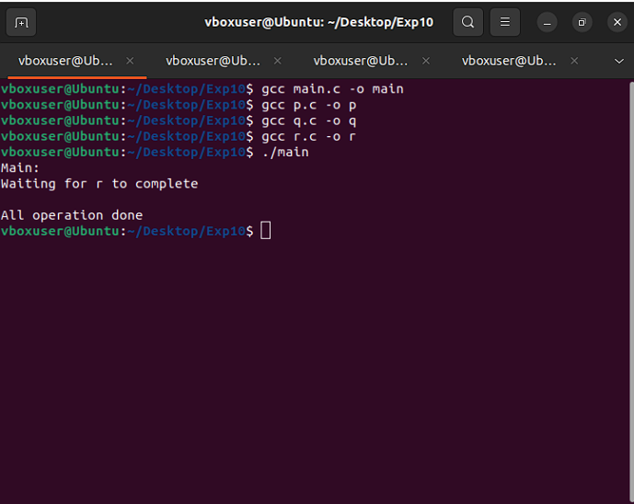

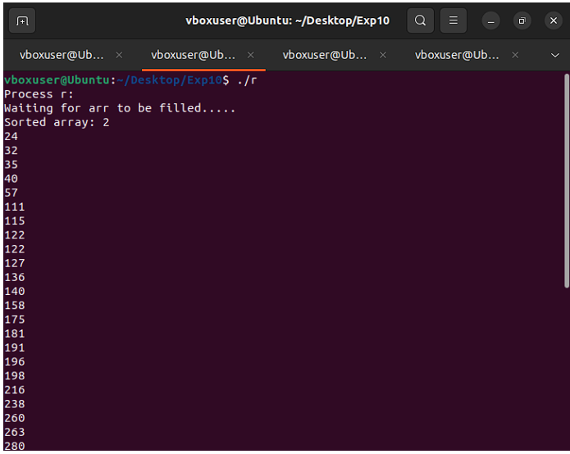

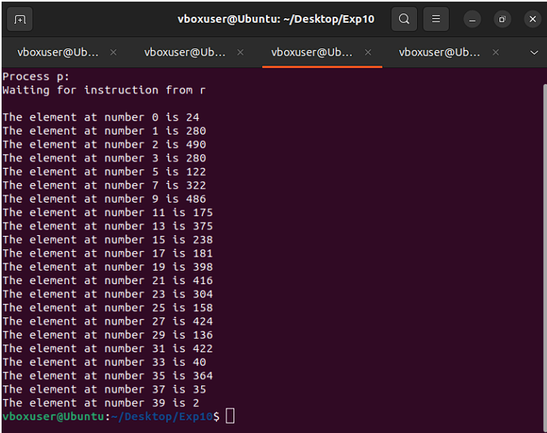

**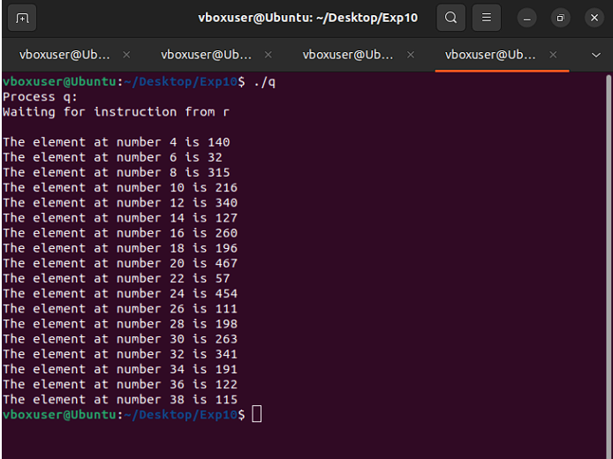  
  
Conclusion:** In this experiment we have learnt how to implement semaphores.